Patrick Alarcon
EZ Autocare
Group 27: Team Diversity
UML Diagrams
Class Diagram
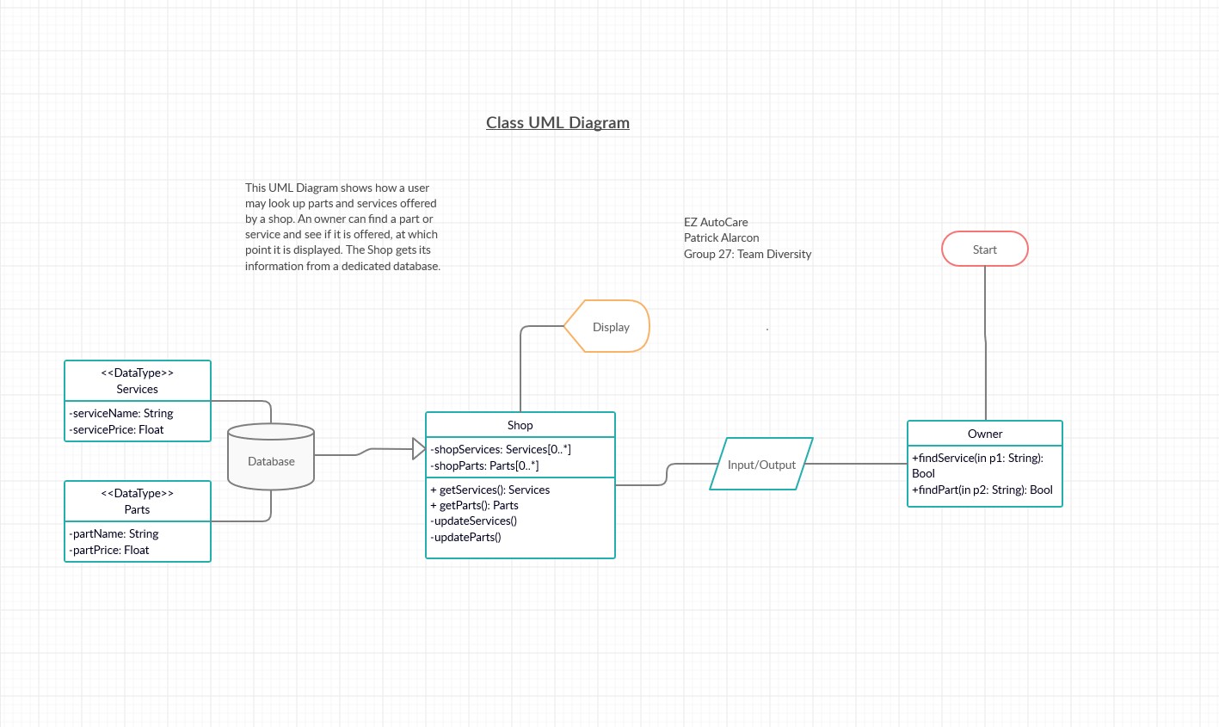

Sequence Diagram
